CSE370 : Database Systems
Assignment 02 | Spring 2025
ID : <22301202> | Name : Khandoker Md. Ragib Ahsan

No 1 Query  (as Plain Text) | Select first_name,last_name,email,phone_number,hire_date,department_id from employeeN where hire_date=(select max(hire_date) from employeeN);
No 1 SS  (of Query & Output  in Shell) | 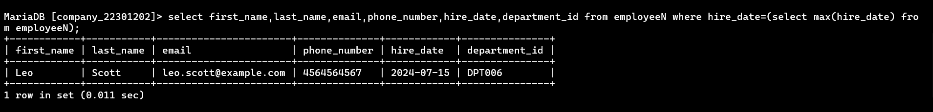
No 2 Query  (as Plain Text) | Select first_name,last_name,employee_id,phone_number,min(salary) as salary,department_id from employeeN group by department_id;
No 2 SS  (of Query & Output  in Shell) | 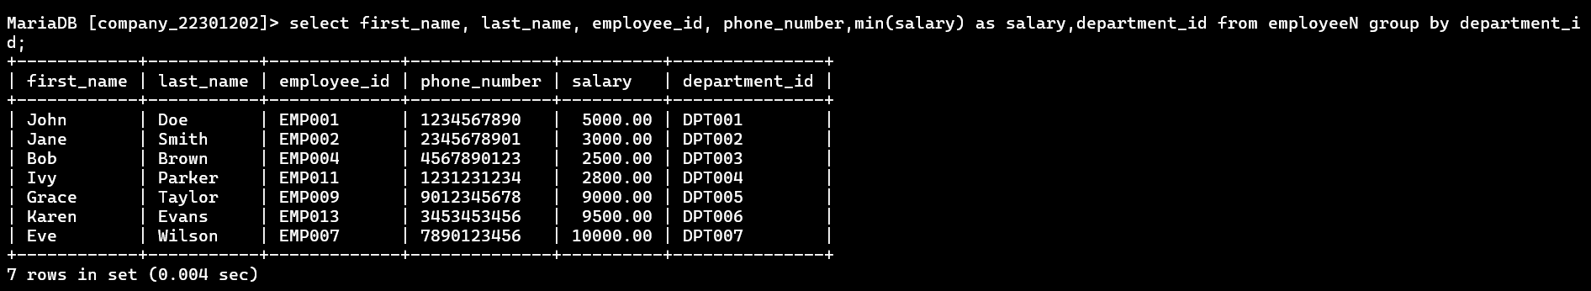
No 3 Query  (as Plain Text) | Select first_name,last_name,employee_id,commssion_pct from employeeN where department_id=’DPT007’ and commission_pct(select commission_pct from employee where department_id = ‘DPT005’);
No 3 SS  (of Query & Output  in Shell) | 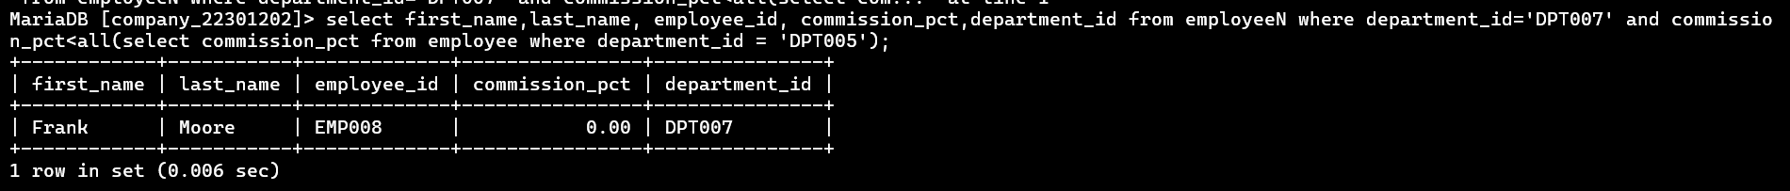
No 4 Query  (as Plain Text) | Select department_id,count(*) as total_employee from employee group by department_id having max(salary)<=30000;
No 4 SS
(of Query & Output
in Shell)
No 5 Query  (as Plain Text) | Select department_id,job_id,commission_pct from employeeN e1 where commssion_pct<(select max(e2.commission_pct) from employeeN e2 where e2.department_id=e1.department_id);
No 5 SS  (of Query & Output  in Shell) | 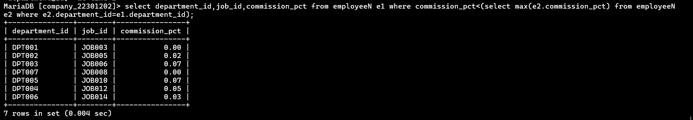
No 6 Query  (as Plain Text) | Select manager_id from employeeN group by manager having min(salary) > 3500;
No 6 SS  (of Query & Output  in Shell) | 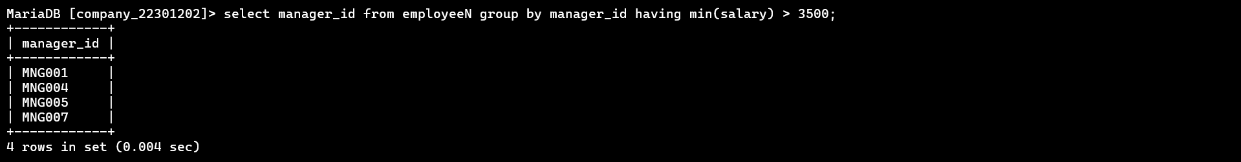
No 7 Query  (as Plain Text) | Select first_name, last_name,employee_id,salary,department_id,commission_pct from employee e1 where commssion_pct = (select min(commission_pct) from employee where manager id = e1.manager_id);
No 7 SS  (of Query & Output  in Shell) | 